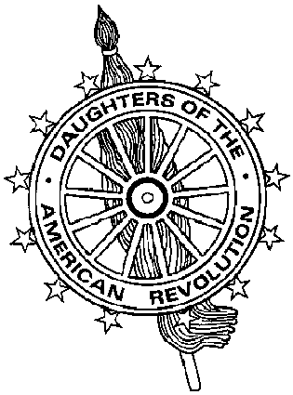
Virginia Daughters of the American Revolution
DAR Scholarship Committee
Mrs. James J. Rafferty, Sr., DAR Scholarship Chairman
10101 Sanders Ct., Great Falls, VA 22066-2526
703-759-3483 (tel) 703-893-7481 (fax) catheraff@aol.com (e-mail)

Cover Sheet for State Scholarship Applications

NAME OF APPLICANT

NAME OF SCHOOL

IS APPLYING FOR (please check one):

__________ VIRGINIA DAR AMERICAN HISTORY SCHOLARSHIP

__________ VIRGINIA DAR SCHOLARSHIP

__________ VIRGINIA NURSING SCHOLARSHIP

AND IS SPONSORED BY:

NAME OF DAR CHAPTER

___________________________________________
Name of Chapter Regent/Scholarship Chairman

___________________________________________
Address

___________________________________________
City/State/Zipcode

_________________________ ___________________________________________
Date Telephone Number

Rev 2001

