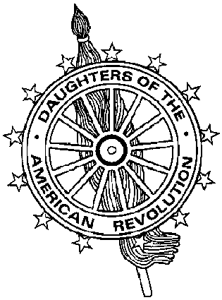
Virginia Daughters of the American Revolution
DAR Scholarship Committee
Mrs. James J. Rafferty, Sr., DAR Scholarship Chairman
10101 Sanders Ct., Great Falls, VA 22066-2526
703-759-3483 (tel) 703-893-7481 (fax) catheraff@aol.com (e-mail)

Fact Sheet for State Scholarship Applicants

Listed below are the scholarships awarded by the Virginia DAR. No affiliation with the State or National Societies is necessary to qualify for these scholarships. DAR members’ children are also eligible to apply.

American History Scholarship

Application forms are included in the national packet. Please follow instructions on the form. A high school senior in the upper one-third of the class AND planning to major in American History may apply. The applicant shall submit with the application:

- A letter of not more than 1,000 words setting forth the reasons for desiring an education in American History.
- A transcript of grades, class rank (if applicable and available) and test scores (SAT or ACT), extra-curricular activities and honors received.
- The financial need form.
- A recommendation from the principal or guidance counselor and the instructor in American History.

STATE WINNER $1,000 Second Place Winner $500

The State Winner’s application will be submitted to the National Society for consideration for the $8,000 American History Scholarship awarded by the National Society Daughters of the American Revolution.

Virginia DAR Scholarship

Awarded to a high school senior who plans to work toward a degree in the field of science, medicine, conservation, ecology, forestry, home arts, genealogical research or American History. The winner MUST attend a Virginia college or university.

STATE WINNER $1,000 Second Place Winner $500

Virginia Nursing Scholarship

Awarded to a high school senior who will continue her/his education at an accredited Virginia school of nursing.

STATE WINNER $1,000 Second Place Winner $500

Deadline on all scholarship applications is February 1st. They are to be sent to the
State DAR Scholarship Chairman.

Winners will be announced at the Virginia DAR State Conference in March.

All checks are made payable to the institution the recipient will be attending and will be sent in August to the recipient.

Note: Please be sure all applications have the sponsoring Chapter’s name on it.

Rev 2001

