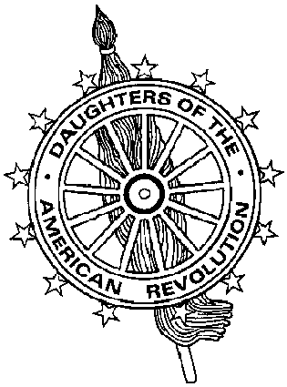
Virginia Daughters of the American Revolution
DAR Scholarship Committee
Mrs. James J. Rafferty, Sr., DAR Scholarship Chairman
10101 Sanders Ct., Great Falls, VA 22066-2526
703-759-3483 (tel) 703-893-7481 (fax) catheraff@aol.com (e-mail)

Financial Need Form

Father or Guardian |  | Mother
Address |  | Address
Employer/Position | Annual Income | Employer/Position | Annual Income
Number and Ages of Dependents in Family Other than Applicant

Other Information Concerning Financial Assets and Obligations Which Would Explain Your Need

Student Income and Resources

Estimated Costs – Academic Year | Tuition/Fees $
Estimated Costs – Academic Year | Room and Board $
Estimated Costs – Academic Year | Books and Supplies $
Estimated Costs – Academic Year | Other Costs $
Estimated Costs – Academic Year | Total Estimated Costs $
Amount you will be able to contribute toward your education $

Please list any other pertinent information the committee should know on the reverse side.

Sponsored by (DAR Chapter) _____________________________ Date ____________________

________________________ __________________________ _______________________
Signature of Father/Guardian Signature of Mother Signature of Applicant

Rev 2001

