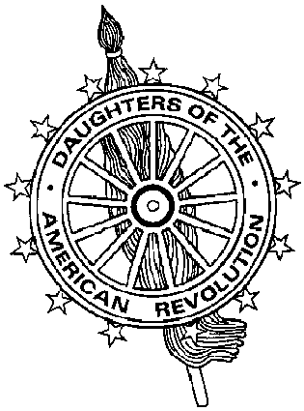
Virginia Daughters of the American Revolution
DAR Scholarship Committee
Mrs. James J. Rafferty, Sr., DAR Scholarship Chairman
10101 Sanders Ct., Great Falls, VA 22066-2526
703-759-3483 (tel) 703-893-7481 (fax) catheraff@aol.com (e-mail)

Virginia DAR Nursing Scholarship Application

First Place $1000 Second Place $500

Name of Student |  | Social Security Number
Permanent Address |  | Telephone Number
College or University you plan to attend

Class Rank/Class Size | Name of High School | Cumulative GPA/Scale
Test Scores | SAT | ACT

Instructions

The Applicant shall:

- Be a student in a senior class of an accredited Virginia high school.
- Plan to continue his or her education in a Virginia school of nursing.
- Include a letter of not more than 500 words givings reasons for interest in pursuing a career in nursing.
- Include a transcript of high school grades.
- Include a letter of recommendation from a teacher or a guidance counselor well acquainted with the applicant.
- Include a Financial Need Form.

Award is made based on merit and financial need. Applications are to be sent to the State Chairman at the above address prior to February 1st. The award must be used in the year in which it is granted.

Rev 2001

