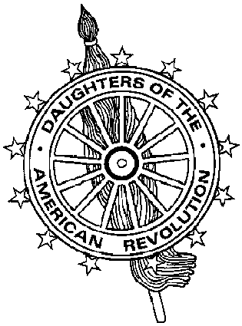
Virginia Daughters of the American Revolution
DAR Scholarship Committee
Mrs. James J. Rafferty, Sr., State Chairman
11771 Arbor Glen Way, Reston, VA 20194-1582
703-772-5544 (cell) 703-467-9564 (fax) cathe@catherafferty.com (e-mail)

Virginia DAR Scholarship Application

First Places (2) $1000 each Second Place $500

Name of Student |  | Social Security Number
Permanent Address |  | Telephone Number
College or University you plan to attend and degree you intend to pursue

Class Rank/Class Size | Name of High School | Cumulative GPA/Scale
Test Scores | SAT | ACT

Instructions

The Applicant shall:

- Be a student in a senior class of an accredited Virginia high school or home school program.
- Plan to continue his or her education in a Virginia college or university.
- Plan to work toward an undergraduate degree in a field other than Nursing.
- Include a letter by the applicant giving reasons for interest in scholarship.
- Include a transcript of high school grades.
- Include a letter of recommendation from a teacher in the chosen field or a guidance counselor.
- Include a Financial Need Form and Cover sheet.

The sponsoring Virginia DAR chapter will complete the required Cover sheet.

Award is made based on merit and financial need. Applications must be received by the State Chairman on or before February 1st. The award must be used in the year in which it is granted.

Rev 11/ 2006

