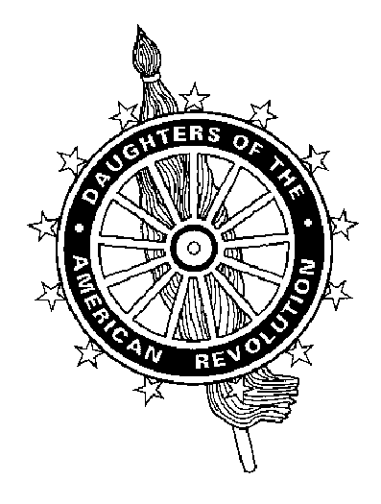 | Virginia Daughters of the American Revolution  Mrs. Patricia H. Mayer, State Regent  Cathi Moore, Program Chairman P. O. Box 7107 Richmond, VA 23221-0107  804.355.5944 mediatemoore@comcast.net

PROGRAM COMMITTEE

The program must be prepared and presented by a member (or members) of the chapter submitting the entry during the period January 1, 2004 – December 31, 2004.

CHAPTER ______________________________________________________________

CHAPTER REGENT _____________________________________________________

ADDRESS ______________________________________________________________

PROGRAM TITLE ______________________________________________________

PREPARED BY _________________________________________________________

NATIONAL # ____________________________

MEMBER OF ____________________________ CHAPTER

DATE AND PLACE OF PROGRAM PRESENTATION _____________________________________

SPEAKER / PRESENTER: Attach qualifications – background, knowledge of subject, etc., on separate page (s).

___________________________________________________________________________________________

INFORMATION ABOUT PROGRAM: Special preparations – permission to duplicate (if needed)

___________________________________________________________________________________________

SOURCE OF MATERIAL: Attach Bibliography, if any, etc. on separate page (s). ___________________________________________________________________________________________

LENGTH OF PROGRAM (Not to exceed 20 minutes) _____________________________

PROGRAM CONTENT:

___________________________________________________________________________________________

PROGRAMS SUBMITTED WILL NOT BE RETURNED.

Program(s) and Chapter Entry Form(s) MUST be received on or before January 5, 2005. Please send to Cathi Moore.

